Think You Can Outrun the Cops? Try Beating Dubai's New Lamborghini Aventador
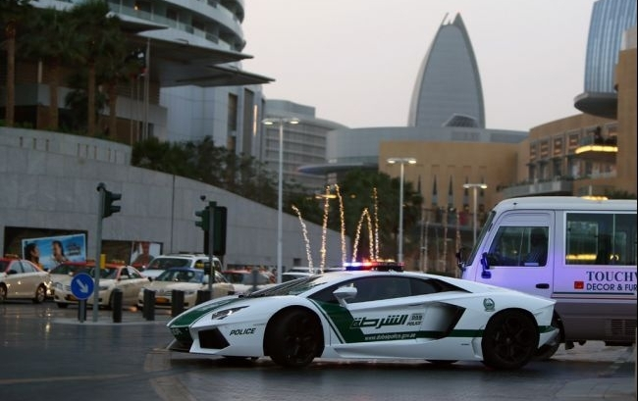
The Dubai Show has performed its latest act. The Dubai Police Department announced on Twitter that high-speed chases will have a clear winner, thanks to a 700-horsepower, $550,000 Lamborghini Aventador patrol car.
Yet wining car races is unlikely to be the motive behind Dubai’s latest purchase.
Dubai is one of the six states that comprise the United Arab Emirates (UAE), a tax haven that investors have been flocking to during the past decade and one of the world's fastest growing tourist and business destinations. A competition for the one city that embodies luxury and ostentatious lifestyles would result in Dubai coming in 1st, 2nd, and 3rd place. Emiratis, the name given to Dubai citizens, embrace this luxurious lifestyle.
Piers Morgan's Dubai Special Report says in this "hedonistic playground" the common theme is "in Dubai, biggest is best." They built the tallest skyscraper in the world, the most luxurious hotel, Palm Jumeirah and The World, the biggest theme park in the world … you name it.
This is why a Lamborghini police car in Dubai fails to surprise me. It should be made out of gold, if anything. Even Italy had one before.

Who:

What:

When:

Where:

Why:

How:

GIST Summary:

