Sherman: Show me the money

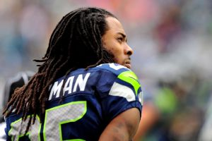

Richard Sherman, a defensive player for the Seattle Seahawks, says that the best way the Seattle Seahawks could show him their appreciation would be by giving him a raise.

"Whatever they feel I am worth, I will take it as respect," Sherman told NFL Network. "It's all about respect in this game, and the only way people show respect is the dollars. We'll see what happens."
Contract discussions between the Seahawks and the star player are ongoing, but a source involved in the talks has told ESPN that the Seahawks aren’t very close to making their deal with Sherman.
Sherman is entering the final year of his rookie contract and is scheduled to make $1.4 million this season. There is no deadline for the sides to reach an agreement, but it is clearly a team priority to secure Sherman to a long-term deal.

Considered by many as the game's top player at his position, Sherman had 18 pass deflections and eight interceptions last season. He was a Pro Bowl star. His most memorable moment came in the final minute of a playoff game against the San Francisco 49ers, when he knocked the ball away from wide receiver Michael Crabtree and into the arms of linebacker Malcolm Smith for an interception that sealed the Seahawks' trip to the Super Bowl

